2015-IL-02 Short Way.odt-Short-Way
0 ---- | I: ---- | II: hard | III: medium | IV: medium

Answer Type: Multiple Choice.

Body

A board consists of black and white squares. A beaver can only stand on white squares. He can walk from a white square to any adjacent white square (horizontally, vertically or diagonally). When he walks this is counted as a single move.

Beaver can also jump over a black square. This can only happen if there is a white square directly behind the black square in the same direction. If beaver can make one or more jumps right after eachother without walking in between, these jumps together are counted as a single move.

The following drawings illustrate this:
Left picture - From b1 to c1 is one move and from c3 to a5 is two moves.
Right picture - From a4 to e2 via c4 is one move.
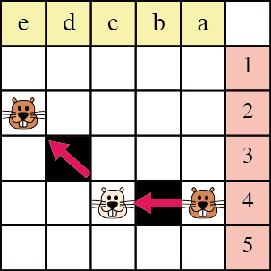
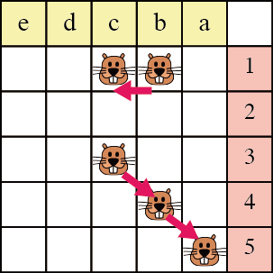

Beaver stands in the upper right corner and wants to get to the bottom left corner.
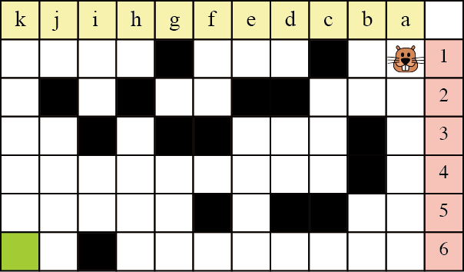

Question

What is the lowest number of moves beaver has to make to reach his destination?

Answer

- 4
- 5
- 6
- 7

Explanation

Correct answer is a.

First step:
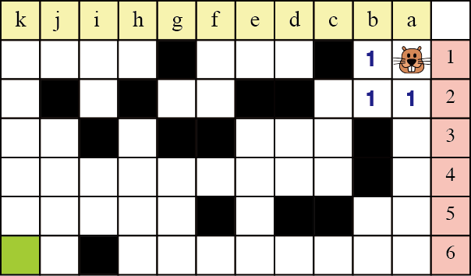

Second Step:
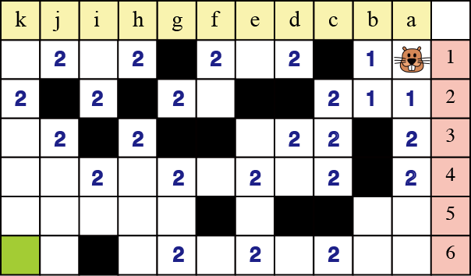

Third step:
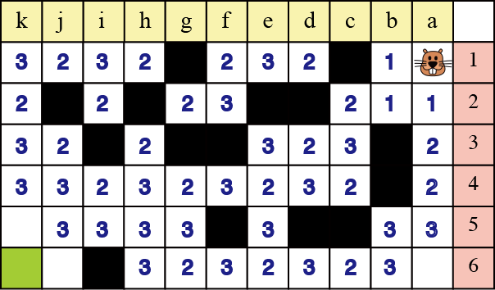

Fourth step:
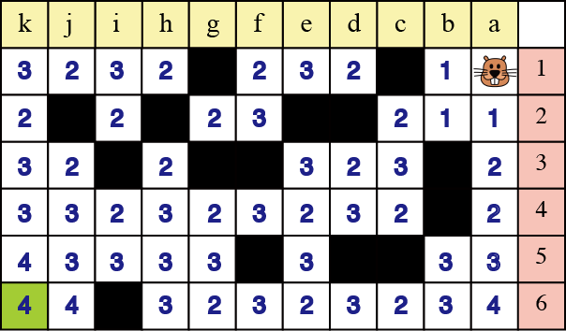

There are multiple ways to get to the destination cell in 4 steps.

[Example steps to reach his destination]
First step : a1 to a2
Second step : a2 to c4 to e6 to g4 to g2 to i2 to i4
Third step : i4 to j5
Fourth step : j5 to k6

It's informatics

This is an application in a Halma-kind of game of the flood fill algorithm. You can use this algorithm to find the shortest distance between cells on a grid.

Keywords

Shortest path
Flood fill algorithm

Websites

http://en.wikipedia.org/wiki/Flood_fill
http://en.wikipedia.org/wiki/Halma

Internal Use

Wording

Comments

The table has the Israeli order.
Working Group 1 changed several things; there is another example of moves, an explanation of the solution.

Graphics

in the graphics folder:
2015-IL-02-Short_Way-1.{png,svg} (Tomohiro Nishida, Japan)
2015-IL-02-Short_Way-2.{png,svg} (Tomohiro Nishida, Japan)
2015-IL-02-Short_Way-3.{png,svg} (Tomohiro Nishida, Japan)
2015-IL-02-Short_Way-4.{png,svg} (Tomohiro Nishida, Japan)
2015-IL-02-Short_Way-5.{png,svg} (Tomohiro Nishida, Japan)
2015-IL-02-Short_Way-6.{png,svg} (Tomohiro Nishida, Japan)
2015-IL-02-Short_Way-7.{png,svg} (Tomohiro Nishida, Japan)
2015-IL-02-Short_Way-c1.png (Maiko Shimabuku, Japan)
2015-IL-02-Short_Way-c2.png (Maiko Shimabuku, Japan)

Files

All additional files for this task (graphics, scripts, etc.)
2015-IL-02 Short Way.odt (this file)
graphics/2015-IL-02-Short_Way-1.png
graphics/2015-IL-02-Short_Way-1.svg
graphics/2015-IL-02-Short_Way-2.png
graphics/2015-IL-02-Short_Way-2.svg
graphics/2015-IL-02-Short_Way-3.png
graphics/2015-IL-02-Short_Way-3.svg
graphics/2015-IL-02-Short_Way-4.png
graphics/2015-IL-02-Short_Way-4.svg
graphics/2015-IL-02-Short_Way-5.png
graphics/2015-IL-02-Short_Way-5.svg
graphics/2015-IL-02-Short_Way-6.png
graphics/2015-IL-02-Short_Way-6.svg
graphics/2015-IL-02-Short_Way-7.png
graphics/2015-IL-02-Short_Way-7.svg
graphics/2015-IL-02-Short_Way-c1.png
graphics/2015-IL-02-Short_Way-c2.png

Authorship

Averbuch Haim Israel averbuchhaim@gmail.com

License

Copyright © 2014 Bebras – International Contest on Informatics and Computer Fluency. This work is licensed under a Creative Commons Attribution-NonCommercial-ShareAlike 3.0 Unported License (CC BY-NC-SA 3.0). Visit: http://creativecommons.org/licenses/by-sa-sa/3.0/

